To install python 3.11
Follow link : https://www.python.org/downloads/release/python-3119/
U will see
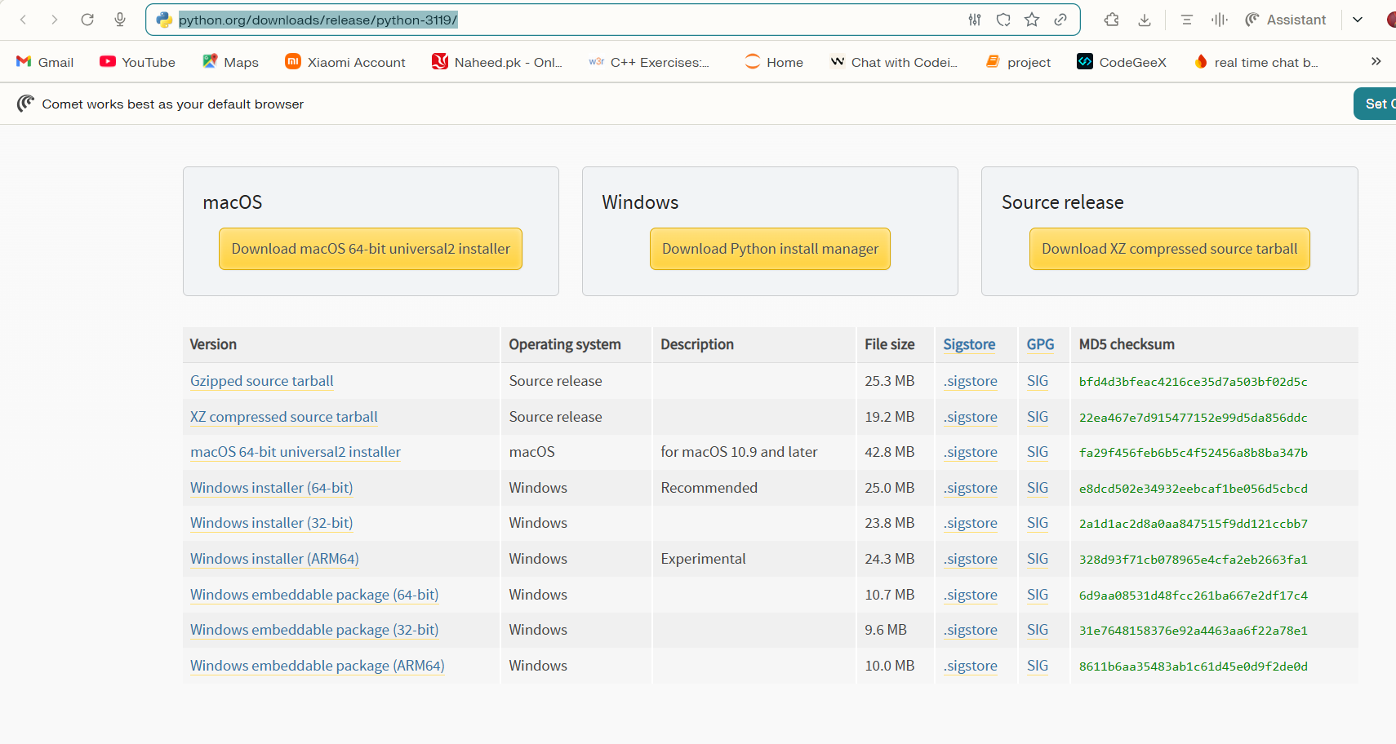

For windows 10 and 11 go for windows instalaler (64 bit): click on it
And download
- ✅ Check "Add Python 3.11 to PATH" — but if it asks about making it the default, don't check that box
Now after installation
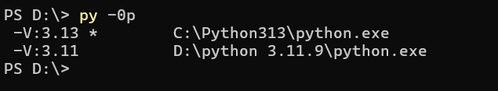
Enter this :
You should see both -3.13 and -3.11 listed. The * is your current default

Delete your old broken venv and recreate with 3.11
cd D:\bottleneck-miner
# Remove the old venv
Remove-Item -Recurse -Force venv
# Create a NEW venv explicitly using Python 3.11
py -3.11 -m venv venv
# Activate it
.\venv\Scripts\activate
# Confirm you're on 3.11
python --version
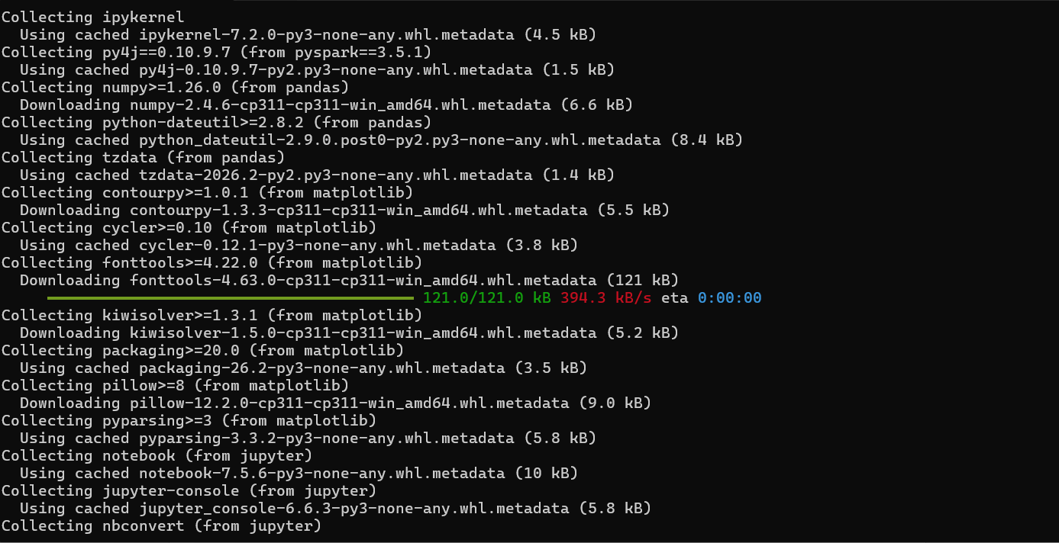
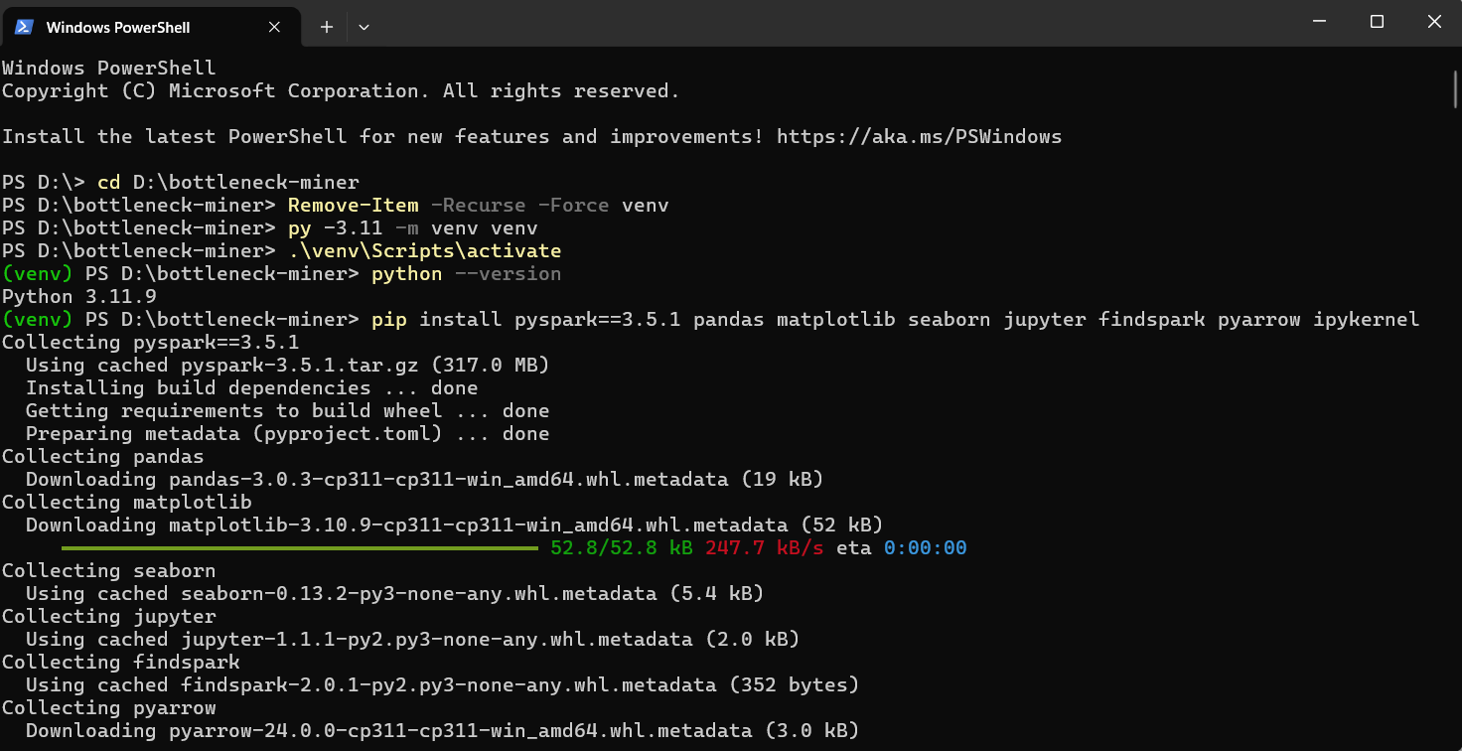

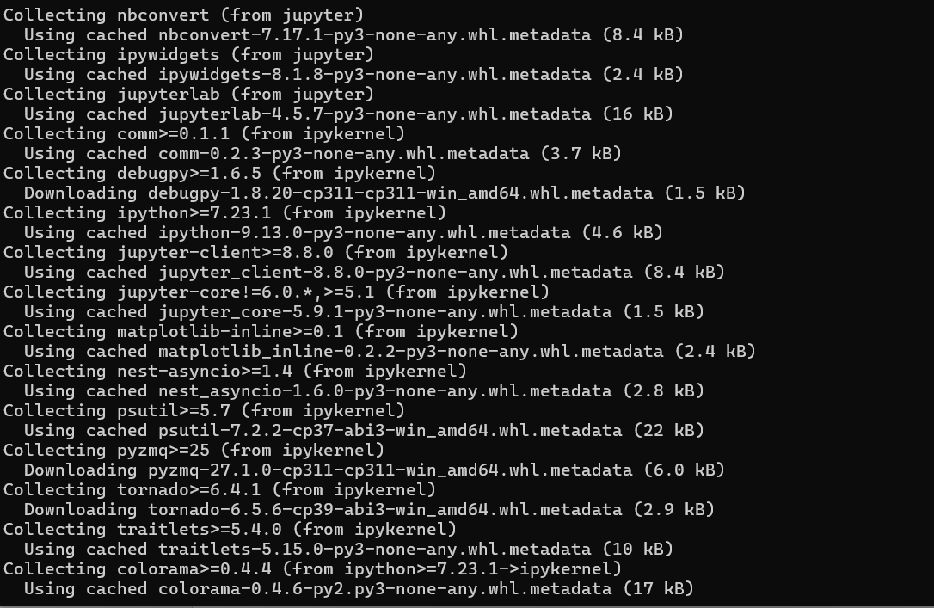
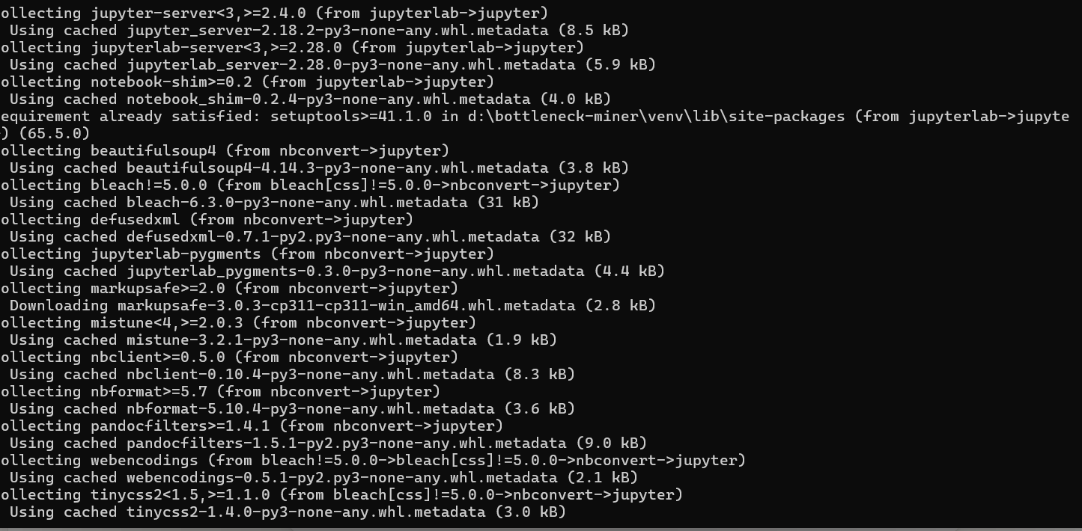

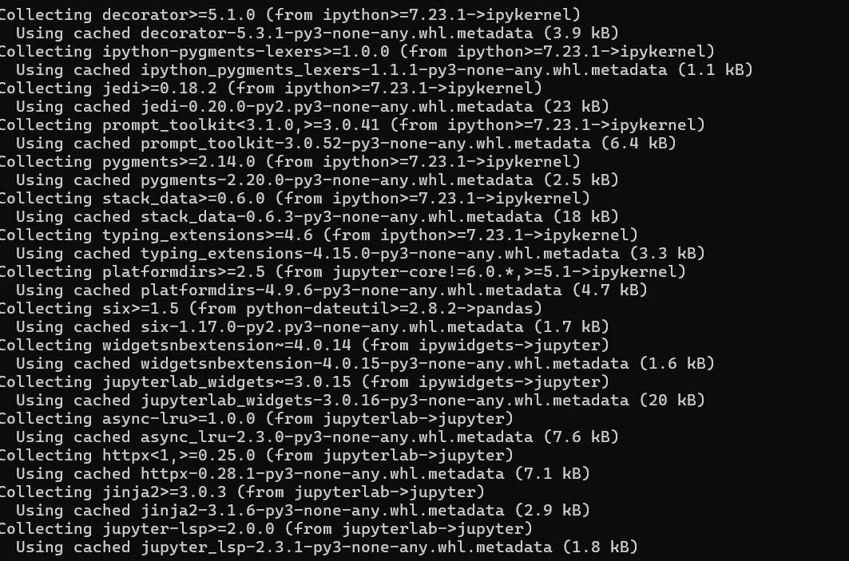
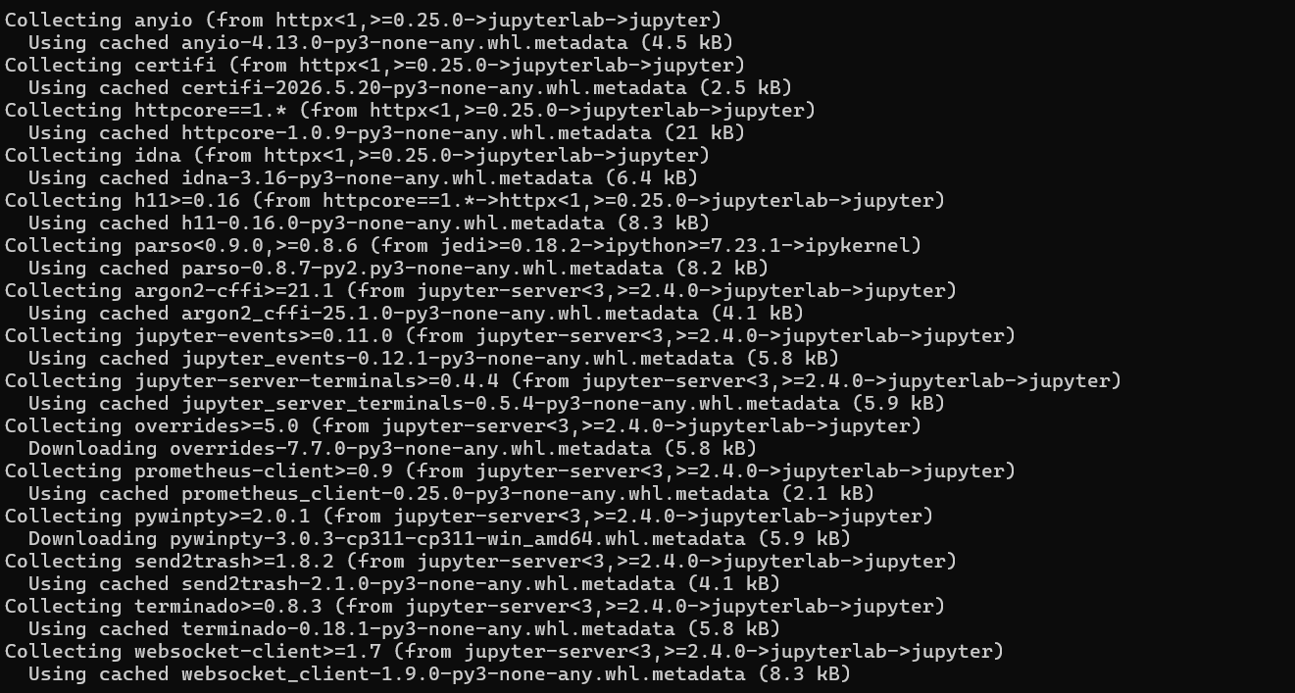

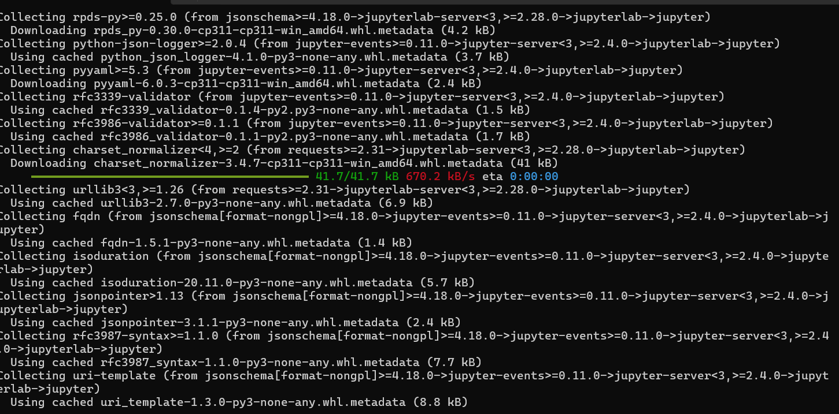
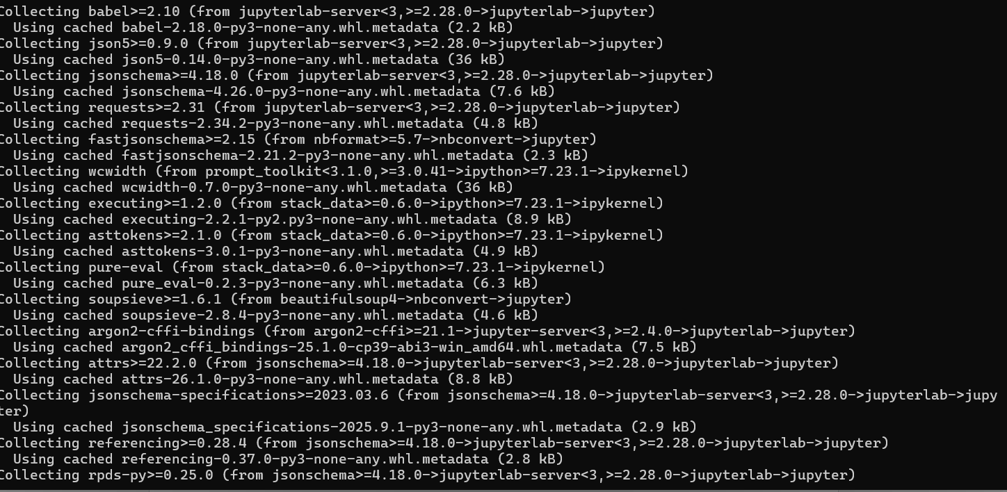

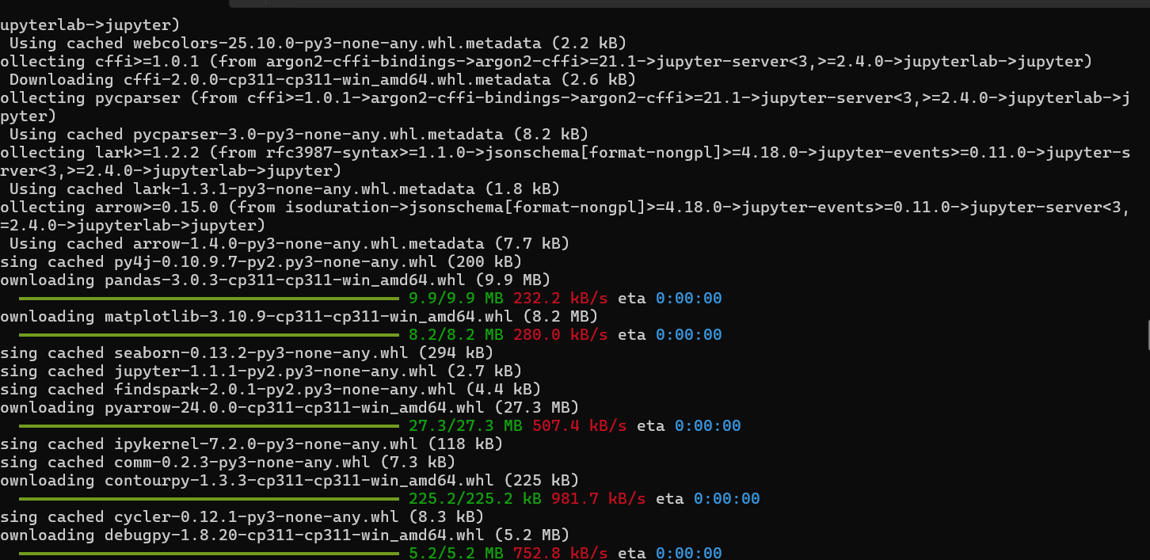

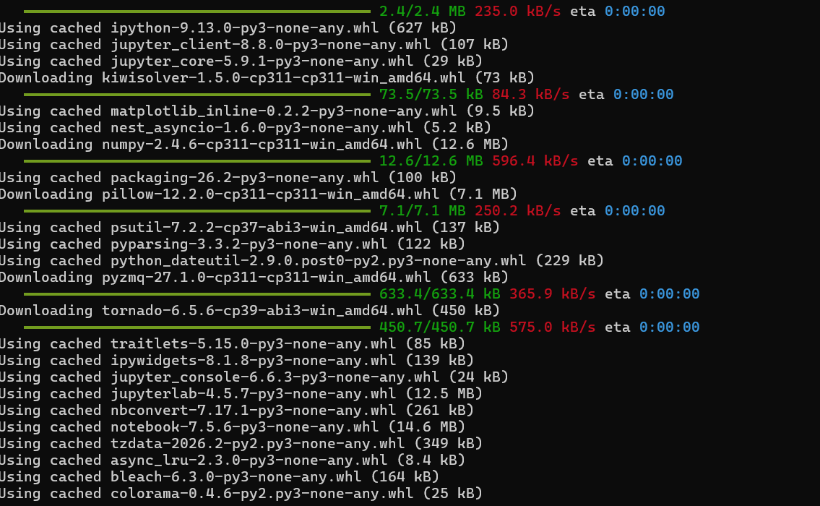


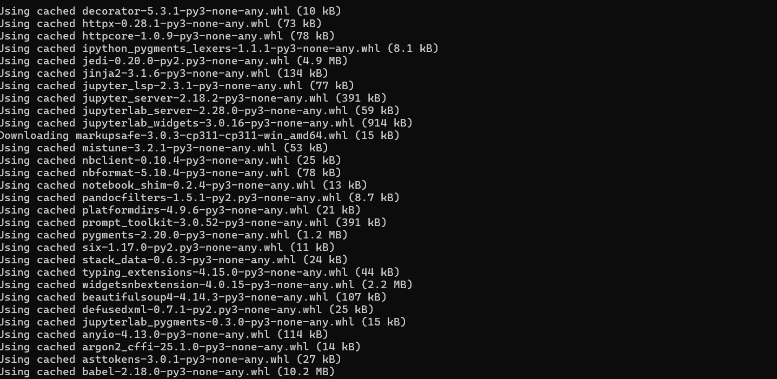
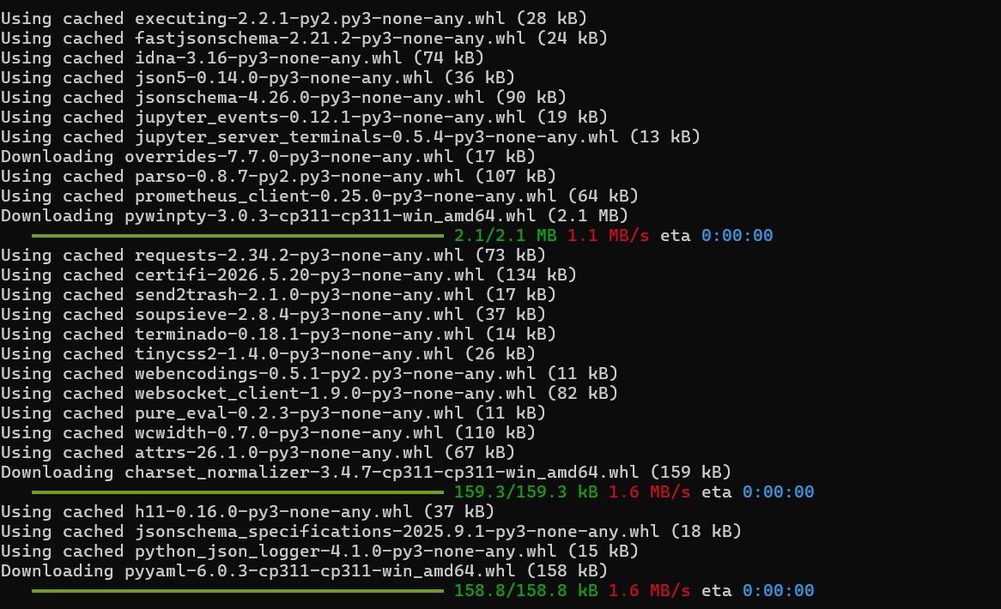

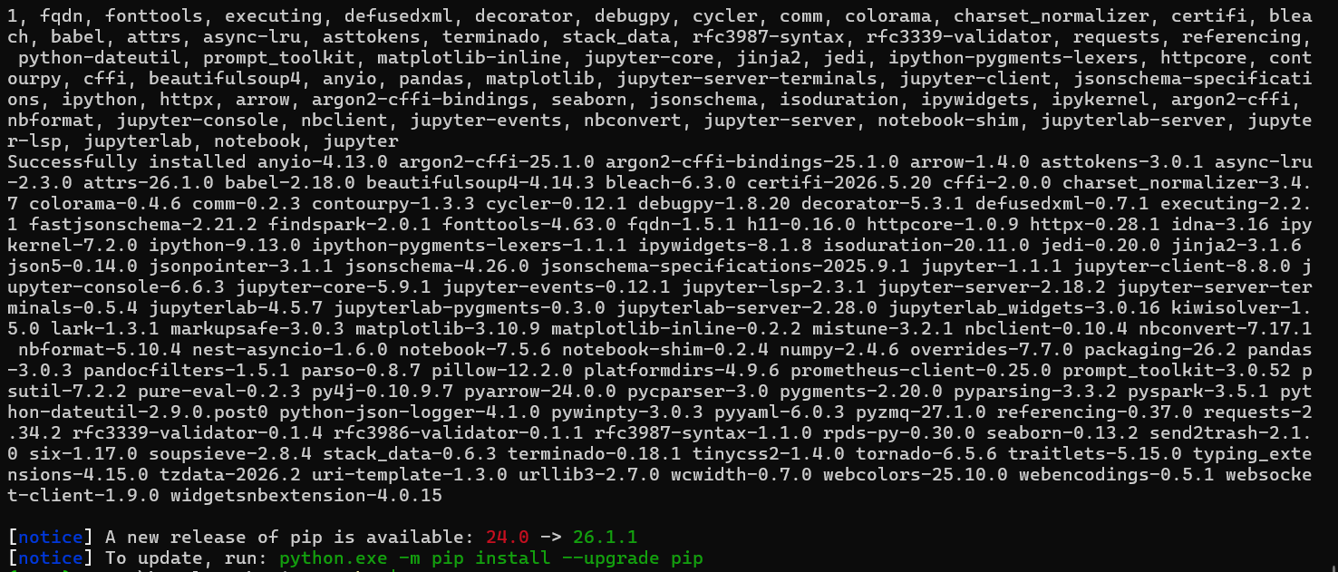
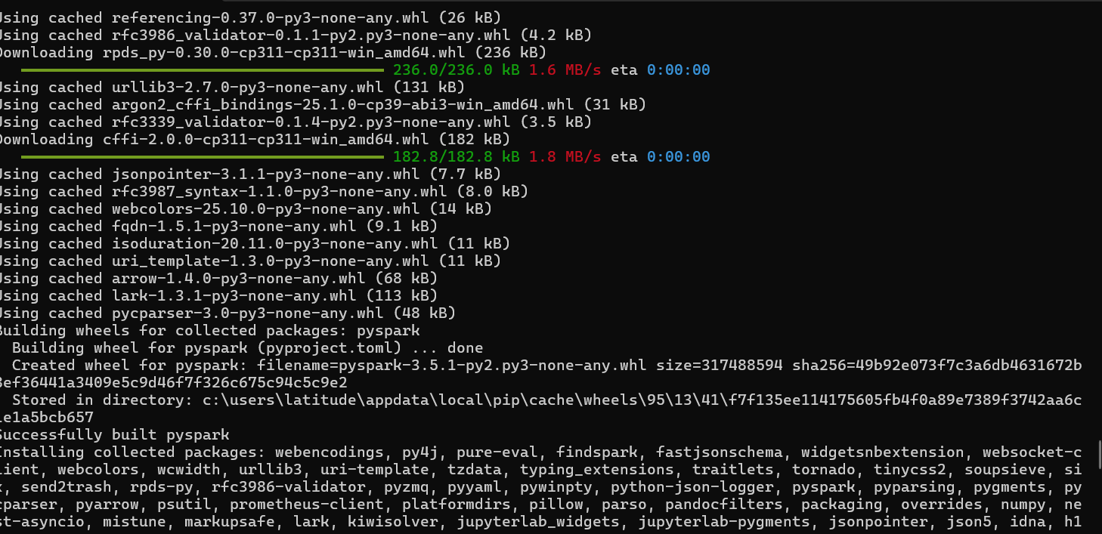

nowStep 4 — Now install PySpark (use 3.5.1 not 3.3.2)
powershell
pip install pyspark==3.5.1 pandas matplotlib seaborn jupyter findspark pyarrow ipykernel

Step 5 — Remove SPARK_HOME env variable (critical!)
Your system likely has SPARK_HOME pointing to D:\Spark\spark-3.3.2-bin-hadoop3\ — this is what causes findspark.init() to pick up the old broken version instead of the pip-installed one:
# Check if SPARK_HOME is set
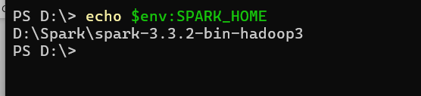
echo $env:SPARK_HOME

# If it shows D:\Spark\..., remove it:
[System.Environment]::SetEnvironmentVariable("SPARK_HOME", $null, "User")
[System.Environment]::SetEnvironmentVariable("SPARK_HOME", $null, "Machine")
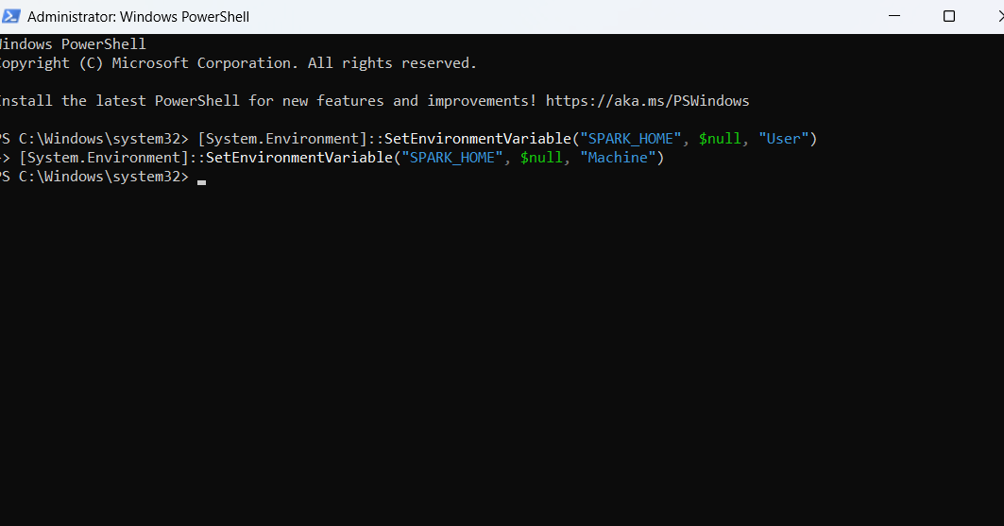

Then close and reopen VS Code terminal completely.

Now :
1. Open a fresh normal PowerShell
Close that Administrator window, then:
powershell
PS > echo $env:SPARK_HOME
You should see nothing (blank line).
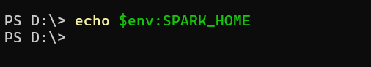

Activate your 3.11 venv
cd D:\bottleneck-miner
.\venv\Scripts\activate
python –version
Confirm PySpark is coming from the venv
Still in the activated venv:
powershell
python -c "import pyspark; print(pyspark.__file__)"
